Camp Nor'Wes

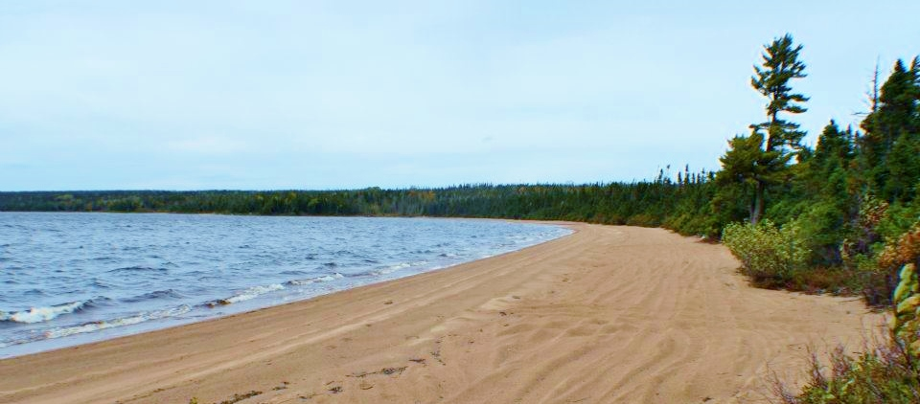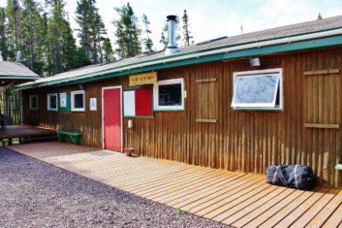

General Information for Jamborees

About Camp Nor’Wes

Camp Nor’Wes is the Newfoundland and Labrador Council Provincial Campsite. It is supported by a Camp Warden during the summer and fall. Provincial Events are typically hosted here. All Scouting groups are encouraged to experience this excellent facility.

Location
Camp Nor'Wes is located in Eastern Newfoundland near the town of Port Blandford and is close to the southeastern portion of Terra Nova National Park. The west side of the campsite borders on Northwest Pond. The pond drains to the east through Northwest River into Trinity Bay.
Coordinates for Google Earth (in Degrees and Decimal degrees) 48.4213, -54.2610.
To locate the site on Google Maps, enter this URL:
https://www.google.ca/maps/@48.4213,-54.2610,16z?hl=en

Camp Nor’Wes Phone Number and Cell Service
In the event that a person or group cannot be contacted by cell phone in an emergency while on site, the camp Warden's phone number is (709) 682-0790. This phone may be unattended at times but there is an answering machine and this is checked frequently.
Cell service is somewhat limited on site but is best in the area of the participant’s camping area. Please keep calls as short as possible.

Access
During the spring, summer and fall, Camp Nor’Wes is accessible by motor vehicles, including school busses and trucks. In the winter, access is usually best by snowmobile, skis or snowshoes. It is about 7 km from the main highway (Route 1 - TCH) to the main campsite. The road crosses the Newfoundland ‘Trailway about I km in from the main highway. The ‘Trailway must be crossed with care as it is popular with ATV riders and also motor vehicles.
There is a gate over Northwest Brook about 2 km from the main site. This gate is usually locked when the site is not open. Should you plan to visit the site outside of scheduled events, please contact Scout Service Centre at 1-709-722-0931 during business hours or email nlcouncil@scouts.ca.
Care must be taken when using the road as it is generally narrow with many blind hills and turns and is wide enough for two cars or pickups to pass slowly and carefully. If you meet a larger vehicle, such as a bus or a truck with a trailer, you may have to back up and pull off the main road. ATVs and dirt bikes frequently use this road.
There are three narrow bridges on the road near the campsite and all vehicles must yield to oncoming vehicles or pedestrians already on the bridges.
Around the campsite, vehicles must drive slowly especially when there are pedestrians and other vehicles on site.

Camp Nor’Wes Site Facilities
The Camp Nor’Wes site can accommodate large and small groups. There are several large permanent buildings including the main lodge, first aid post during jamborees, administration building, Scout shop/multipurpose building, showers, a few indoor toilets and several outhouses, six cabins and a gazebo fire pit. Two cabins are also set up with propane appliances and lights. The four campsites near the Northwest Pond also have a gazebo, a toilet and a water tap. They are accessible on foot or by ATV and a trailer. The main buildings are supplied with electrical power from a large generator. The cabins are powered by a small portable generator.
There are 116 campsites around the northeast side of the campsite. There are several strategically placed water taps throughout these sites. Temporary toilets are put in place for large events such as Jamborees. There is no electrical supply to these sites.
All the 116 sites are accessible by larger vehicles such as pickup trucks for unloading and loading equipment. Larger vehicles such as buses are restricted to the main roads. There are restrictions on site access during large camps.
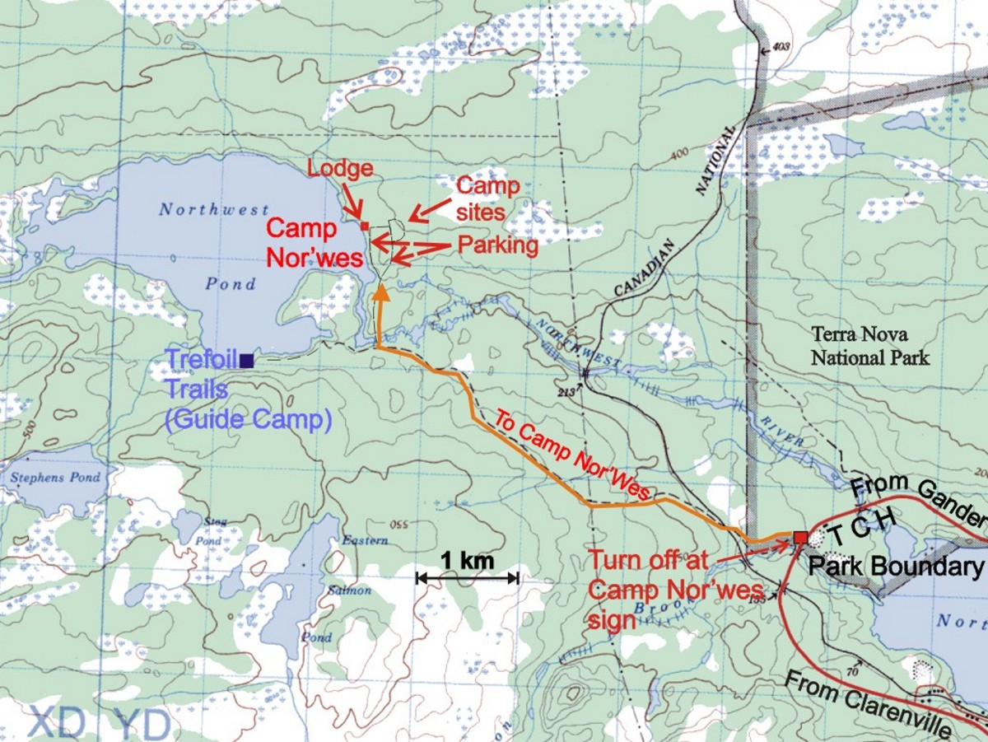
There is a small parking lot near the main lodge that may be used for smaller events. During jamborees, the smaller lot is restricted/off limits. The large parking lot south of the main campsite must be used.

Map showing location of Camp Nor’Wes and the location of the turnoff from the TCH (Route 1)

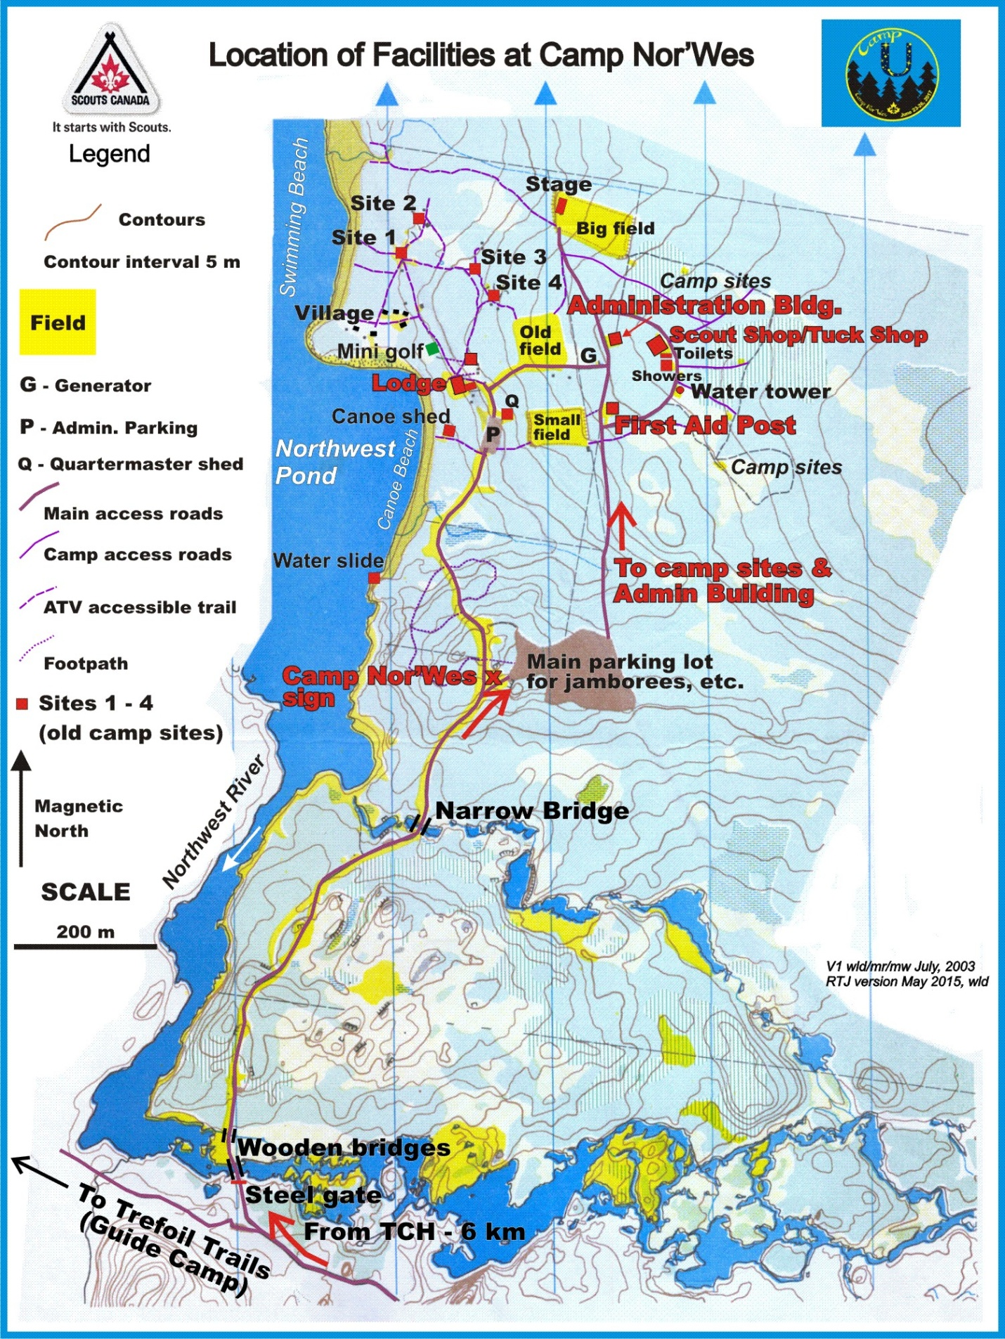

General Safety, Cleanliness, Hygiene and Environmental Items

Health and Safety
Scouts Canada endeavours to provide as safe an environment as possible at Camp Nor’Wes. Camps will be inspected for potential safety issues by the staff prior to participants' arrival. Should you see anything that you consider unsafe anywhere in the camp please contact the Administration staff as soon as possible.
During Provincial Jamborees, the first aid post is staffed by St. John Ambulance personnel 24 hours a day, from noon on Friday until noon on Monday. In the event of an injury or illness please take the person to the first aid post. Youth members must be accompanied by at least two scouters. Groups have submitted physical fitness forms for all on site. These will be held at the first aid post.

Toilets/Showers
Portable toilets and outhouses are available throughout the Camp Nor’Wes site for the Jamboree. The toilets will be cleaned daily. Make every effort not to mess up the toilets.
Wash your hands after using the toilet and before all meals. Hand sanitizers will be provided for all toilets. Every campsite should also have a sanitizer available.
Indoor and Outdoor showers are located adjacent to the Shower building which is located to the left (south) of the Tuck Shop building. During jamborees, the indoor showers are for adults and those requiring accessible washrooms only. The outdoor showers are for the youth. These will be available 24 hours per day. If you see a problem with a toilet or a shower please report it to a staff member.

Fire Precautions
- Fire protection and prevention is the responsibility of all in camp.
- The utmost care must be taken to prevent fires and burns.
- Ensure you have a fire extinguisher (Class A,B,C) readily available at each campsite.
- Make sure all appliances are turned off when not in use.
- Close propane tanks when not in use.
- Lanterns should not be left burning unattended in any tent.
- Older model stoves/lanterns using white gas/Coleman fuel/Naphtha are forbidden.
- Candles of any sort, including tea lights must not be used in tents.
- Use of Charcoal BBQs is forbidden.
- No open fires in the campsite areas.
- No generators in campsite area

In Case of Fire
If a fire breaks out on a campsite, if safe to do so, use a fire extinguisher to put out the fire. Groups are responsible for bringing their own extinguishers. Whether or not the fire appears to have been extinguished, immediately inform the staff.
If the fire cannot be extinguished using the on-site fire extinguisher(s), immediately evacuate the area, travelling upwind from the site of the fire. As soon as it is safe to do so, inform the staff.
If you see a fire outside the camping area, immediately notify a Jamboree staff member (identifiable with a neckerchief).
In the event that the decision is made to undertake a full evacuation, air horns will be used to notify Jamboree participants. A series of short blasts of the air horns shall signal that an evacuation is underway and all participants are to quickly make their way to the muster stations on the Swimming Beach. Short Blasts = Swimming Beach. A series of long blasts from the air horns shall signal that an evacuation is underway and all participants are to quickly make their way to the muster stations at the Large Parking Lot. Long Blasts = Large parking lot - we are leaving!
There will be four muster stations at each evacuation location. At registration, each group will be assigned a muster station, designated A, B, C or D. Please ensure that each member of your group knows the appropriate response to a fire, and to which muster station the group has been assigned. A member of each group must have with him/her at all times a list of all of that group’s Jamboree participants, as well as their emergency contact information.
Jamboree staff wearing safety vests will direct participants to the appropriate muster area where other staff shall direct participants to the specific muster stations.
Upon hearing the notice to evacuate do not delay, nor return to your campsite for anything. Immediately proceed to the designated evacuation site.

Allergies
Camp Nor’Wes is a peanut-free area. There are several participants with allergies to a variety of things, including scents and food. Please inform your neighbours if there is an allergy concern within your group. All allergies should be reported on the medical forms, but make sure that relevant info is shared.

Cleanliness and Garbage
Please keep Camp Nor’Wes and your camp sites as clean as possible. Put garbage in green or black garbage bags. Garbage bags will be collected at least once a day by noon. Place bags in front of campsite before you leave for the morning activities. If you see garbage away from your site, please place it in a garbage container. Keep food items in animal-proof containers. We do not want animals attracted to your sites. Note: Do not store personal gear in black garbage bags and leave out in the open. They could end up in the garbage.

Environment
Do not cut down any trees. Bushes that have grown in the tent sites may be removed. A rake would be an asset in grooming your site.
Please separate recyclable beverage containers (juice boxes, bottles and cans, and soft drink cans and bottles) from your garbage and place them in a transparent or blue garbage bag. These will be collected during the regular garbage collections.
Grey water (dish water and hand-washing water) must be strained before being dumped in the woods. This is very important to keeping wildlife away from the sites. All scraps should be placed in the garbage.

Animals
No animals are permitted on site unless required for Medical Reasons, i.e., Service Dogs. Permission must be obtained from the Jamboree Administration prior to the Jamboree.

Provincial Jamboree General Program Information

There is a separate booklet relating to each jamboree program. This will be shared closer to the date of the event. Generally, the daytime program schedule has been arranged to allow time to get ready for the start of events in the morning, including a 30 break between the two morning session, for travel and snack break, have lunch and get to the next event, have supper and participate in evening activities. At least two Scouters from each Group must attend the events with their youth members. It is expected that all groups will participate in the events.

Safety during the day
At each program event, the coordinator will be equipped with a radio, so emergencies can be relayed to the first aid group, St. John's Ambulance, and to administration. Each event coordinator will have a basic emergency first aid kit. It is recommended to bring along a few Band-Aids and hand sanitizer. Emergency contact lists will be kept by the groups and medical information will be at the first aid post.

Safety during the evening
The jamboree team will give advance notice to participants where they can contact a member of the Jamboree team if any issue arises during the evening, before lights out at 11:00.p.m. At any time of day, and particularly after 11 p.m., participants can go to the first aid building as there will be someone with a GMRX radio who can reach all other camp staff.

Health and Safety during Program Events
Be prepared for the weather. It may be cool; it may be sunny and hot; it may be rainy. Participants should all have their own water bottle. Scouters should bring extra sunscreen and be on the lookout for potential sunburn victims. Please have the youth wear a t-shirt when out on the water or playing on the beach. There is an increased risk of sunburn in these areas due to reflection off the water. Even on overcast days people can quickly get sunburn. Always wear a hat. A hat that covers the top of the ears is best.
Should there be any participants with special needs attending an activity, please inform the Activity leaders.
All activities are in radio contact with the admin team and the First Aid Centre. Should there be a problem, assistance can be called in. There will be a First Aid Kit at each activity site.

How to Identify Staff at the Provincial Jamboree
Staff, whether volunteer (Offers of Service), Scouts Canada employees or contract staff (cleaners and cooking staff) will be identifiable by the special neckerchief they will be wearing during the Jamboree. Some may also be wearing name tags. The design/colour of the necker will be announced in the program booklet.

Be on time
It is important that participants arrive at the location of their Camp Nor’Wes daytime events by the scheduled starting time. You should be ready to depart from your campsite in the morning and afternoon at least 20 minutes before the starting time of your next event. You can easily get to any activity from your campsite in 20 minutes. Groups that are late arriving can cause delays in getting started and they may miss out on part of the activity.

Cooperation
It is expected that the youth and the Scouters follow the guidance of and instructions from the activity leaders. They are volunteers who are here to make sure that all the participants have fun. Scouters are expected to remain with their group during activities. If there is a problem, please discuss it discretely with the activity staff.

Please assist if requested
Scouters may be asked to assist with the running of some events, such as assisting with fitting youth into their lifejackets. Please help out if requested. Scouters are also expected to take part in the activities.

Jamboree Services
Medical Services Team
There will be 24 hour medical staff coverage on site during the entire Jamboree period. Complete Hospital Facilities are located 30 minutes away by car or ground ambulance. There will be some facilities available to store medication that must be refrigerated.

Camp Safety
If any issues arise relating to safety, speak to any OOS. The First Aid post is also available 24 hours a day during the Jamboree. There will be staff on duty 12 noon Friday until 2:00 p.m. Monday.

The Tuck Shop
The Tuck Shop is located in the large building across from the tent sites. The hours will be posted. The Tuck Shop will have for sale a variety of cold drinks, candy and bars. Cash sales only, please.

Lost and Found
To help you find your misplaced items, please put your name or other identifying label on your items. Similarly with Group equipment such as Coleman Stoves. (These have been misplaced and without a group name on them, impossible to locate.) A lost and found service will be provided at the Tuck Shop. If you find an item, please hand it in to the Lost and Found desk.

Charging Station
A charging Station for cell phones and other small electronic items will be set up in the Tuck Shop area. The owner of the cell phone (or other device) will be issued a receipt for each item which must be presented when picking up the charged item. There will be a fee of $1.00 per item charged. This is donated to the Brotherhood of Scouting.

Offer of Service – Meal Schedule
Meals for the Offers of Service (OOS) volunteers will be served in the Main Lodge. OOS meals begin with supper on Friday of the jamboree and will end with lunch on Monday of the Jamboree. All OOS must bring their own mess kit, as Styrofoam and plastic will not be provided. OOS will be provided with wash up stations for their mess kit.

OOS Meal times are:
Breakfast – 7:00 a.m. to 9:00 a.m. NOTE: Program begins at 8:30
Lunch – 1:00 p.m. to 2:30 p.m.
Supper – 5:00 p.m. – 7:00 p.m.
Note: Scouts Own at 8:00 a.m. on Sunday

Site Allocations
A few weeks before the Camp begins, Sections will be assigned a number of camp sites based on numbers of participants and Scouters registered. PLEASE NOTE: Cubs, Scouts, and Venturers will typically be in different areas of the campsite so sharing resources between Sections will be, at best, challenging. Every Section/Patrol should be self-contained. However, if this is a issue for groups due to sharing camping resources, every effort will be made to help. Please communicate any such requests as soon as possible to the organizing committee.

There are picnic tables on each site. A rake and shovel would be good items to bring along. Groups are permitted to rake and groom their sites, but not cut down trees.

Please remember that cargo/camper trailers cannot be kept on campsites. They will be parked in the large parking lot for the duration of the Jamboree.

Though there will be opportunity for gear drop off at the site on Thursday. Beginning Friday, vehicles with camp gear will not be permitted to drive directly to their campsite. Equipment may be dropped off on the road by the Supermarket until 1 pm. By 1 pm, all vehicles are required to be off the camp roads and in the parking lot. All youth and Scouters should be prepared to carry their gear at least a half kilometer from the parking lot should the need arise. A limited number of hand carts are available to move gear, however, for convenience, groups may bring their own carts/wagons.

Gear lists for Sections, patrols/lairs are posted on the Jamboree Web site under separate headings.

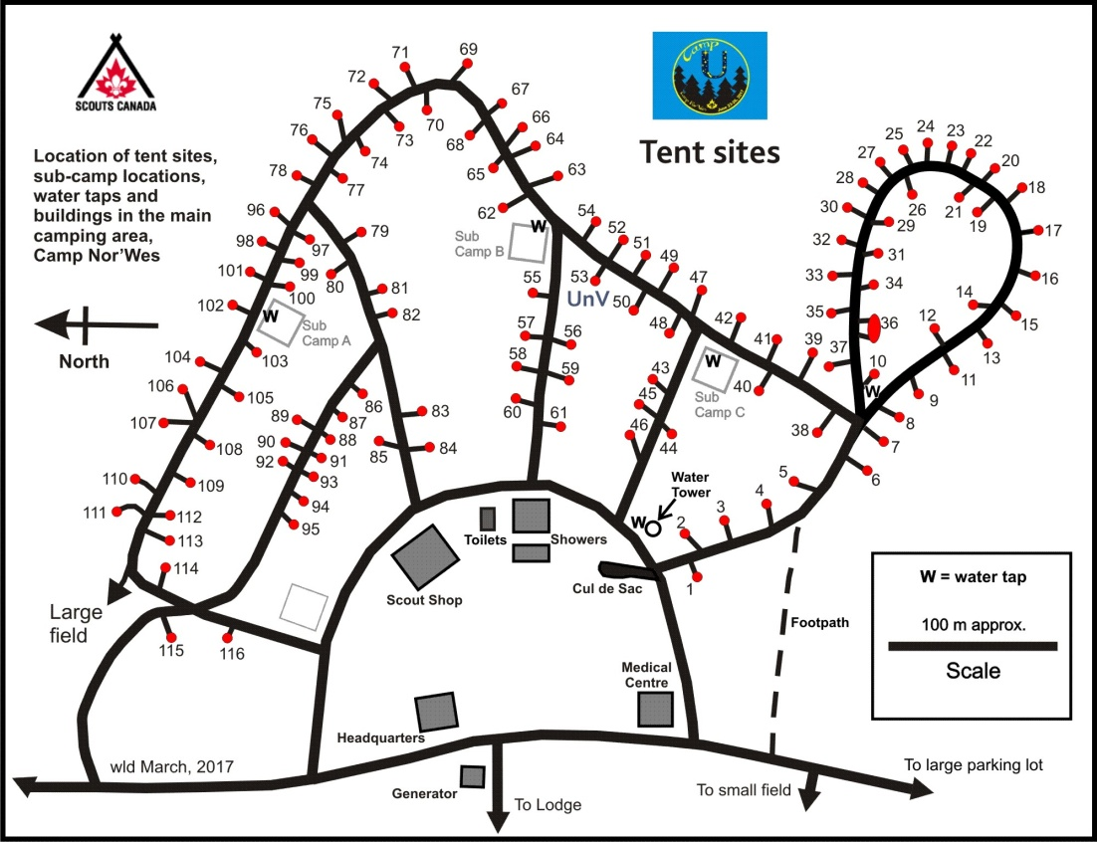
Map of Jamboree Tent Sites

Any other questions?
If you have any other questions regarding the jamboree site, contact the organizing team! We will help in any way we can.

And remember, look for the detailed Program booklet two or three weeks before the event, as registration is finalized. This will contain your group's schedule plus more.

See you at the Jamboree!

